Effective communication is an essential and pivotal cornerstone of modern-day policing.
My Community Alert www.mycommunityalert.co.uk is a free messaging system operated by Humberside Police, Humberside Fire & Rescue Service, and Humberside Office of the Police & Crime Commissioner, giving you live information about incidents happening in your area.
Choose how you receive messages, by either phone or email, how often you want to hear from us and about the issues that matter to you.

When something happens that you’ve told us you want to hear about, your local officer will send you the details, whether that’s notice of a road closure due to a collision or a burglar who has been caught in a nearby garden.
Subscribe to My Community Alert to be the first to know about issues that might affect you or your family.


REPORT HATE CRIME HERE

Join your local
INDEPENDENT ADVISORY GROUP
Have a voice. Make a difference
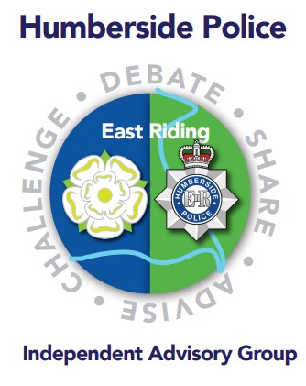
Looking to join the Special Constabulary?
Then visit www.wearehumbersidespecials.co.uk or scan the QR code below.


PC 988 Carl Osler
Community Cohesion Officer
East Riding Of Yorkshire
Pearson Park Police Station
Hull, HU5 2TD
Mobile: 07464649437
Business: 01482 220703

